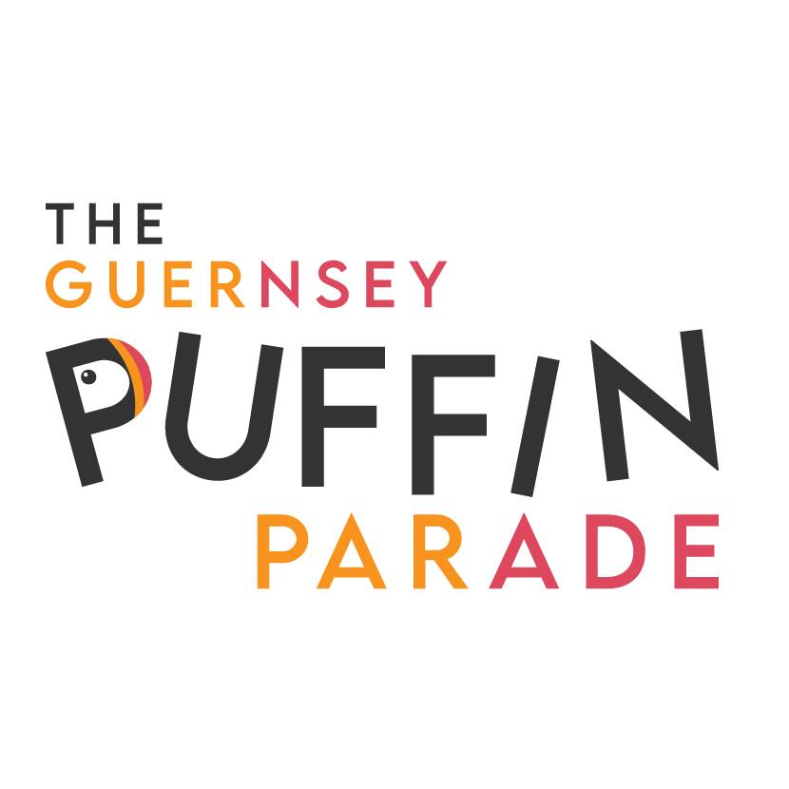
COMMISSION BID

Lot Number: Name of Puffin:

Maximum bid:

Name:

Address:

Home Phone:

Mobile:

Email Address:

Payment must be made immediately after the auction, either by BACS or credit/debit card. Account name: Autism Guernsey LBG, Account No: 24801760, Sort Code: 30-93-73, Reference: “Puffin Name & Lot No”

All puffins must be collected from St. Pierre Park by 12 noon on Wednesday 13th September.

Thank you for supporting the work of Autism Guernsey and the GSPCA
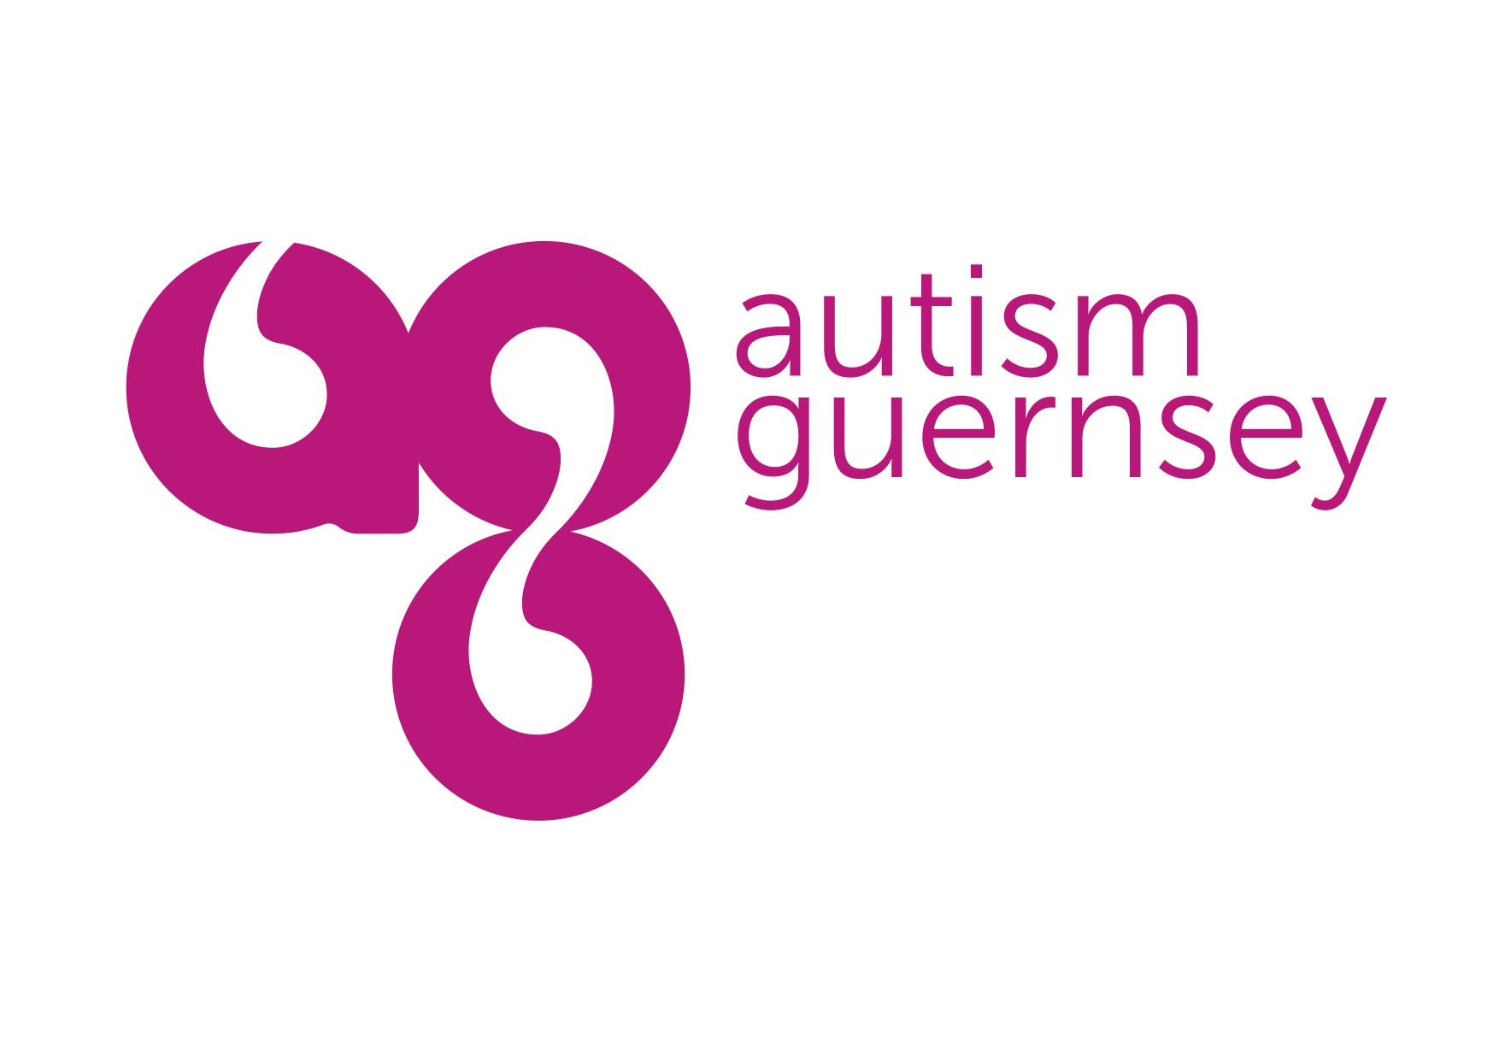
Please email this form to bids@autismguernsey.org.gg

